- Add a DocumentTotal attribute to the SalesInvoice document. Add it to the document form at the bottom, under the products table, field should have the “Label field” type.
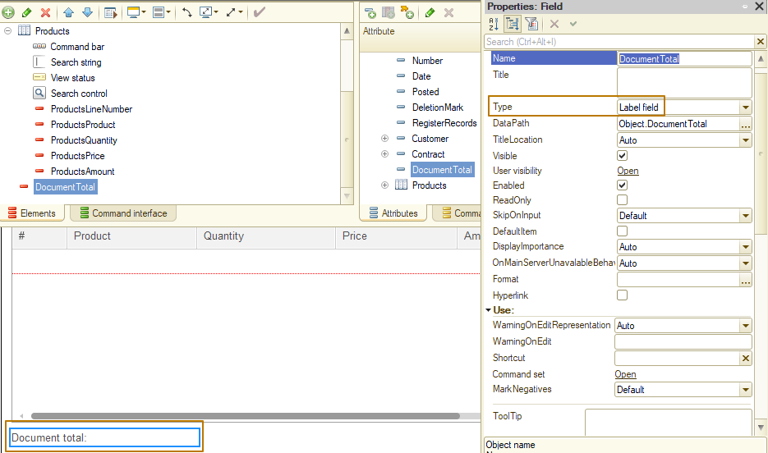
- Now you need to implement automatic calculation of the new attribute when changing in the Products tabular section. To do this, use the event OnChange of the form table. The events themselves and their handlers will be discussed in one of the following lessons.
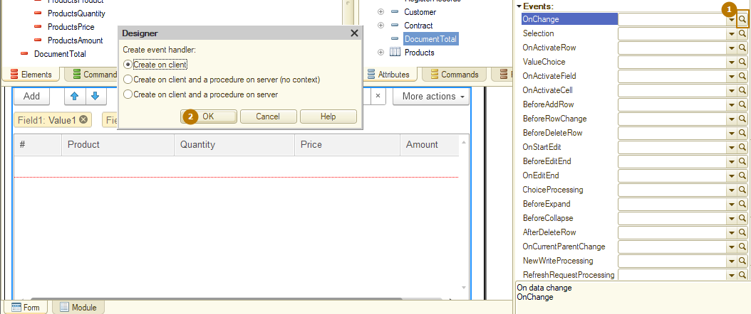
Write an algorithm of the calculation and put the result to the Object.DocumentTotal attribute:
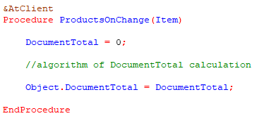
Check that the program is working correctly, to do this, open the document and change the amount in the Products tabular section, for example, by changing the quantity, price, or adding/deleting rows.
- The next step is to add to the program the concept of the minimum selling price, below which the goods cannot be sold. Add the MinimumSalePrice attribute to the Products catalog, then add a price check when the price or product changes in the Products tabular section of a SalesInvoice document.
Use the OnChange event of the Price and Product columns to control the minimum price, because when a product changes, its minimum price may be higher than that specified in the Products row.
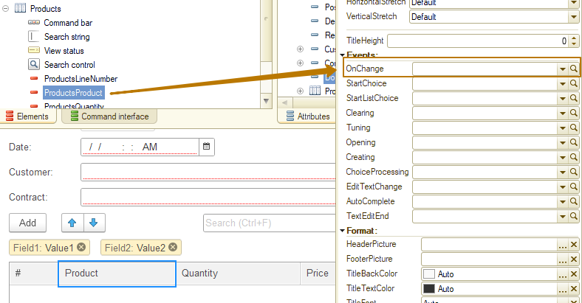
- You need to create the MinimumSalePriceOfProduct(Product) function with the &AtServerNoContext directive, which returns the minimum price of the product by getting the attribute value from the object by reference: Product.MinimumSalePrice. We will talk more about directives and execution context a little later, for now we only note that such an operation is only possible on the server.
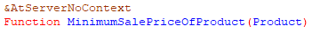
The algorithm should be as follows: when a user changes the price or product, it is necessary to check the minimum price, if the current price is lower than the minimum, you need to change it to the minimum and display a message to the user “Minimum sale price for (product presentation) is (minimum price)”. Text in brackets means that you must substitute the current product and price (without brackets) in the message.
Don't forget to avoid code duplication, and you should also keep the existing recalculation of the amount when the price changes, even if the price was changed to the minimum from a code.
- Add the ValidUntil attribute (Date) to the CounterpartyContracts catalog. This is an optional attribute, if it is not filled, then the contract is valid indefinitely. Create an item form and, in addition to the ValidUntil attribute, add the "Days left" field to it, which shows the remaining number of days under the contract from the current date to ValidUntil. If ValidUntil is empty, do not display this field on the form. The “Days left” value should be recalculated, as well as enabling / disabling the visibility of this form field on changing the ValidUntil value.
Tip: Use the global context method ValueIsFilled(<value>) to check if a date is filled. This method allows you to check the completeness of values of almost all types: primitive, reference, collections, even a value with the Undefined type.
Tip: Use the global contex method CurrentDate (client and server) or CurrentSessionDate (server only) to get the current date. Read about both of these methods at the Syntax-assistant.
To control form element’s visibility, use the Visible property of it. You can access a form element using the Items property (Items.<ElementName>) in the form module. Thus, the visibility of the MyFormElement field can be changed using the code:
Items.MyFormElement.Visible = True;
Items.MyFormElement.Visible = False;
After adding the ValidUntil attribute, you need to create an item form for the CounterpartyContracts catalog. Then add DaysLeft form attribute with a Number type.
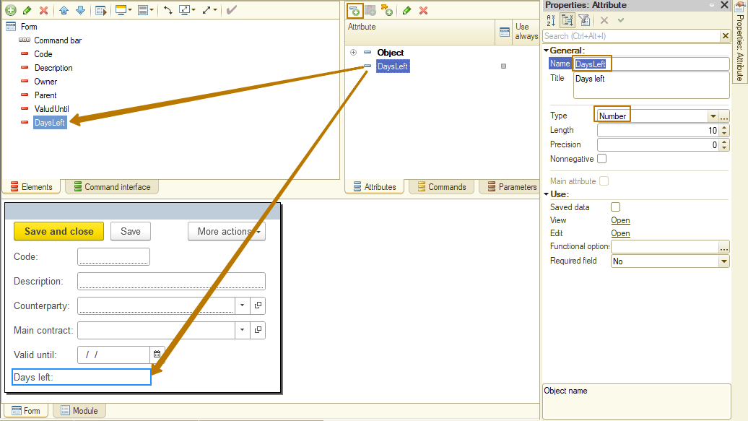
Since you also need to check whether the “Days left” field should be displayed when opening the form, add an event handler for the OnOpen event of a form.
You can use the built-in function Round() to round numbers.
Example:
RoundedNumber = Round(Number);

Attribute ValidUntil is filled:
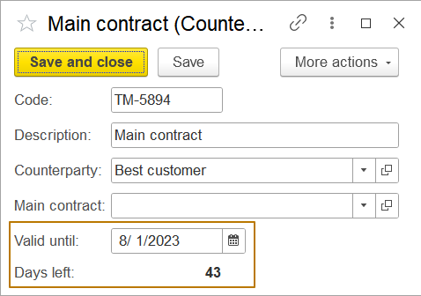
Attribute ValidUntil is empty:
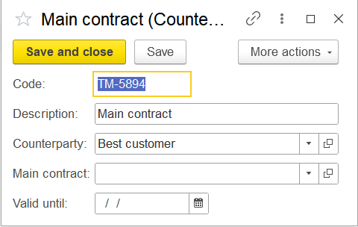
- Create a common form called TestCollections, add it to the MasterData subsystem (don’t forget to turn on “Include in the command interface” property of the form). Create the SortArray command at this form.

Example:
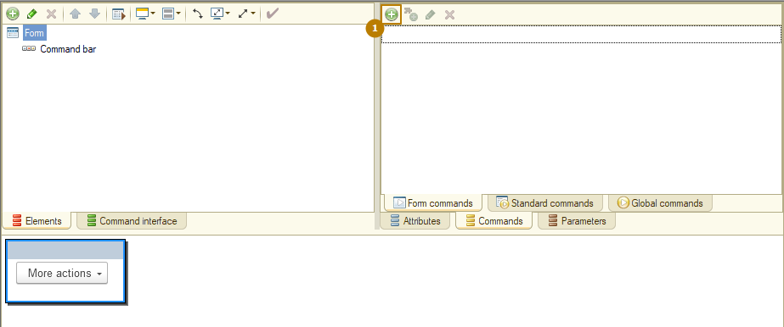
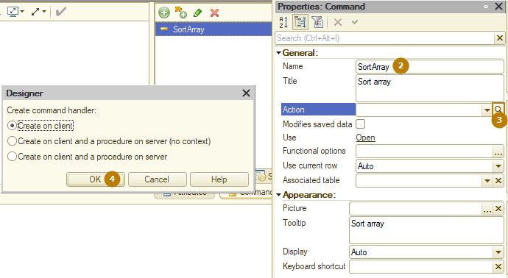
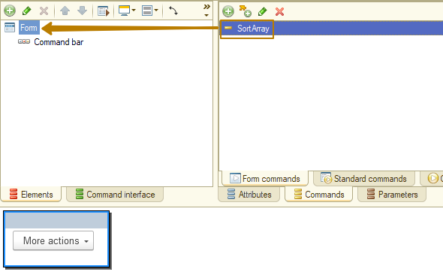
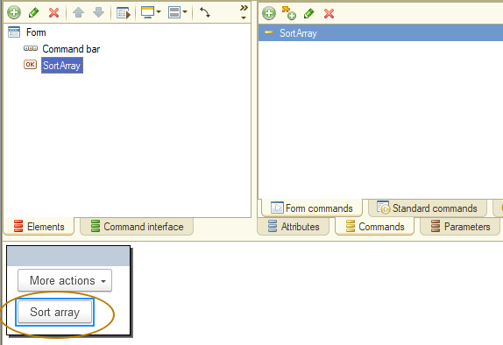
- Create a function SortedArray(<Array>) that takes an array of numbers as a parameter and returns an array of numbers sorted in ascending order. To implement such a function, create a list of values inside the function and use its methods:
- LoadValues() to load values from an array
- SortByValue() to sort by value
- Find in the syntax assistant a method for unloading values from a ValueList into an array
Check if it works by filling SortArray procedure with a code: create a new array, add the numbers 4, 2, 15, 7, 10 to it, then call the new function, writing its return value to a variable, then iterate over each element of the array and show the user its value.
The result:
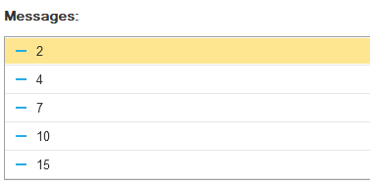
- Create the ShowSelectionFromValueList command, go to the handler procedure of this command at form module, initialize a new ValueList “ActionsToPerform” and add three items to it:
- Value 1, Presentation "First Action"
- Value 2, Presentation "Second Action"
- Value 3, Presentation “Third action”
The ValueList has a ShowChooseItem method to provide a user with a choice of a value from a list, the first parameter of which is an object of type CallbackDescription. A CallbackDescription is a procedure call that will be made after some action from a user, in our case after selecting from a list or closing this list without making a selection. Initialize a new variable with a CallbackDescription object and pass it to the ShowChooseItem method.
CallbackDescription = New CallbackDescription("ShowSelectionFromValueListEnding", ThisObject);
For the Title parameter (of the ShowChooseItem method), enter the text "Choose the action to perform". When creating a CallbackDescription, the first parameter is the name of the procedure to be called upon the occurrence of the action, the second parameter is the module in which this procedure is located, in our case it is the form module in which we write the code, so we point to this form using ThisObject property (this is a property of the ClientApplicationForm object, i.e. the form).
Create a procedure that we specified in the CallbackDescription, note that this procedure must be an Export procedure and must contain two parameters: SelectedElement and AdditionalParameters, you can read more in the syntax assistant for the ShowChooseItem method.
Add code to send a message to a user if he has selected a value from the list.
&AtClient
Procedure ShowSelectionFromValueListEnding(SelectedElement, AdditionalParameters) Export

// SelectedElement is a result of a selection from a list, if the user does not select anything, it's Undefined
If SelectedElement <> Undefined Then
// Send a message to user with data from a selected element
// "Selected element: Value = <Value>, Presentation = <Presentation>"
// Add the code of sending message here
EndIf;

EndProcedure
- Create the CopyAndSearchValueTable command and create client and server handlers for it, because the ValueTable is unavailable on a client side.
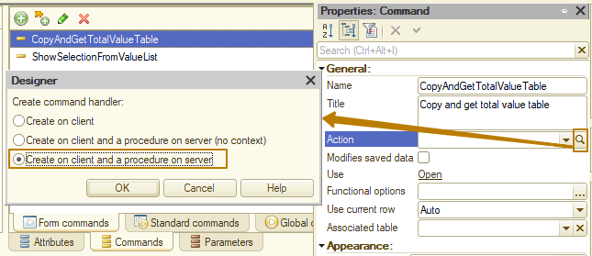
In the server procedure, create a new ValueTable and add three columns to the list of columns: Product, Price, Quantity. Then add 4 rows to the table:
- Product: Cable, 10m; Price: 100; Quantity 24
- Product: Cable, 10m; Price: 103; Quantity 52
- Product: Cable, 15m; Price: 150; Quantity 10
- Product: Cable, 20m; Price: 190; Quantity 200
Now our task is to calculate the total quantity for the Product “Cable, 10m”. This can be done in several ways:
1) Iterate all rows of the table, checking the product in each row, if it is the desired product, then accumulate the quantity in a variable
2) Find the rows of the table in which the Product is equal to the desired one using the FindRows() method of the ValueTable and iterate these rows, accumulating the quantity in the variable
3) Copy the table of values with selection by Product into a new variable, so we will have a new table with rows only for the desired product. Then use the Total(<Column name>) method this new ValueTable to get the sum of the column with numeric values.
Why is it impossible to use the Total() method in the second option? Because the FindRows() method returns an array with the rows of the ValueTable, we cannot use the Total() method for it.
It should be understood that this example does not mean that other options are worse, it aims to demonstrate how to work with the ValueTable using the existing methods of this object.
Use the #3 option to implement this task.
Let’s look at the description of Copy method of ValueTable:
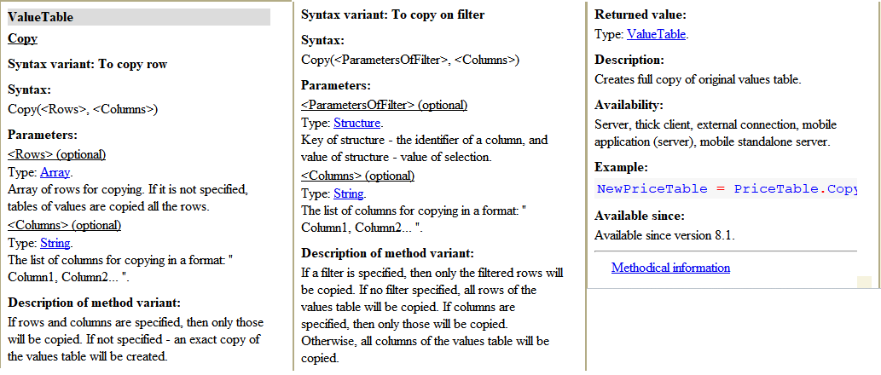
There are 2 options for specifying the selection (which is optional, you can also copy the entire table):
1) To copy row - passing an array of table strings of values to be copied to the new table
2) To copy on filter - passing a structure with a filter, where the keys are the names of the columns, and the values are the values in these columns.
Initialize the RowsFilter variable by creating a structure with the key "Product" and the value "Cable, 10m". Initialize the ProductTable variable by calling the Copy() method of ValueTable passing the RowsFilter variable to it. Then use the Total(<Column Name>) method of this new ValueTable to get the total for the column you passed in as a parameter.
After calculating the total, report the result to a user in the form "Quantity of <Product> is equal to <QuantityTotal>", where <Product> - is a product presentation and <QuantityTotal> is a calculated Total quantity.
- Create the CalculateTotalAtValueTree command and create client and server handlers for it, because the ValueTree is unavailable on a client side. In this task we will work with iteration of a multilevel tree.
We will create a three-level sales tree where the first level is the period, the second is the customer, and the third is the product and amount.
First, let's create the tree columns: Period, Customer, Product, Amount (all with the String type).
Tree structure (for simplicity, I will indicate the levels starting from the first, although in fact the numbering of levels in the tree starts from 0):

Level | Period | Customer | Product | Amount
1 | January 2023
2 | January 2023 | John
3 | January 2023 | John | Water | 1250
2 | January 2023 | Albert
3 | January 2023 | Albert | Water | 480
3 | January 2023 | Albert | Flour | 1000
1 | February 2023
2 | February 2023 | John
3 | February 2023 | John | Water | 2500
2 | February 2023 | Bob
3 | February 2023 | Bob | Beans | 130
3 | February 2023 | Bob | Water | 800

Note: When adding subordinate rows to a tree row, they must be filled in entirely; the values of subordinate rows are not filled based on their parents.
The best way to iterate a tree with a large or unknown number of levels is recursion. If you have not come across this concept yet, I recommend reading about it, but for now we will only note its main principle - a recursive method calls itself. We first need to decide whether our method will be a procedure or a function. A recursive procedure usually accumulates a value in a variable taken as a parameter, a recursive function accumulates it in a variable initialized internally and returns the result.
Let's stick with a function so that the calling code outside of the recursive method is shorter because we don't have to initialize the variable passed inside.
Example:
// function
AmountOfProduct = AmountOfProductAtTree(SalesTree, "Water");
// procedure
AmountOfProduct = 0;
CalculateAmountOfProductAtTree(SalesTree, "Water", AmountOfProduct);
The task is to write a method AmountOfProductAtTree(Tree, Product) that takes a tree and a product name as input and returns the amount for this product among all the tree rows.
An important detail: the rows of a tree can be obtained by accessing its Rows property, the rows of a specific tree row can be obtained in the same way!
In the function, you should initialize the variable with the 0 and then iterate the rows of the tree, accumulating in the variable the amount of only the product that is passed in the Product parameter. When certain conditions occur, or always, you must call the same function inside a loop, passing the current line of the tree into it and adding the result returned by it to the variable.
// beginning of a function
Result = 0;
For Each TreeRow In Tree.Rows Do
// your code
Result = Result + AmountOfProductAtTree(TreeRow, Product);
//…
Call this function by passing "Water" in the Product parameter and send a message to user with the result value in the format "Amount of Water is <Result>".

The end result of what the TestCollections form looks like:
